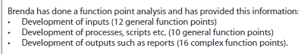

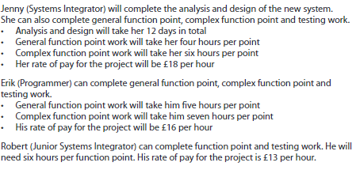

Gfp - 22

Cfp -16

Jenny gfp – 4hrs cfp – 6hrs pay -£18 per hour

Erik gfp – 5hrs cfp – 7hrs pay - £16 per hour

Robert gfp – 6hrs cfp – 6hrs pay - £13 per hour

7 hours a day, 5 days a week, 2 months in total, 8 weeks in total

|  |  |  |  |  |
| --- | --- | --- | --- | --- |
| Workers | Per hour | Per day | Per week | Total Project pay |
| Project Manager | £20 | £140 | £700 | £5600 |
| Jenny | £18 | £126 | £630 | £5040 |
| Erik | £16 | £112 | £560 | £4480 |
| Robert | £13 | £91 | £455 | £3640 |
|  |  |  |  | £18,760 |

|  |  |  |  |  |  |
| --- | --- | --- | --- | --- | --- |
| Workers | General function point | Gfp pay | Complex function point | Cfp pay | Total pay |
| Jenny | 88 hrs | £1584 | 92 hrs | £1656 | £3240 |
| Erik | 110 hrs | £1760 | 116 hrs | £1856 | £3616 |
| Robert | 132 hrs | £1716 | 92 hrs | £1196 | £2912 |
|  |  |  |  |  | £9768 |

TOTAL STAFF PAY = £28,528

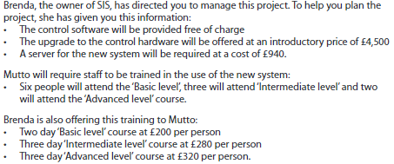

6 basic, 3 intermediate, 2 advanced

|  |  |  |
| --- | --- | --- |
| Number of people undergoing course | Course | Total cost |
| 6 | Basic | £1200 |
| 3 | Intermediate | £840 |
| 2 | Advanced | £640 |
|  |  | £2640 |

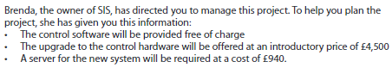

|  |  |
| --- | --- |
| Resource name | Cost |
| Upgrade to control hardware | £4,500 |
| Server for the new system | £940 |
| Tester laptop | £230 |
| High spec laptop | £ |
|  | £5670 |